
Hoagland Youth League

Register until February 22nd at
WWW.HOAGLANDBASEBALL.COM

Late registrations will only be accepted if divisions aren’t full, and there will be a $20 late fee. Don’t wait!!!

Peewee | T-Ball | 8U | Minors | Majors | Koufax/Senior | Family Maximum
$50  Age 3-4 | $65  Age 5-6 | $85  Age 6-8 | $90  Age 9-10 | $95  Age 11-12 | $110  Age 13-14 | $200

A one-time $30 Concession & Park User Fee will be paid at time of registration. Limit one fee per family.
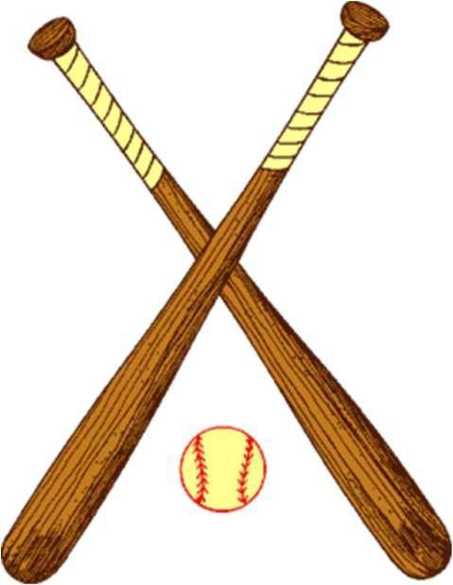
- Player evaluations at St. Joe Hessen Cassel Gym: Sat. March 7th
- Divisions & Times TBD

- Coaches Meeting at the Hoagland Pavilion: Wednesday March 18th
  - Peewee and Tball 6pm
  - All other age Divisions 7pm

- Park clean-up days: Saturday March 21st

- Practices begin the week of March 23th

- Picture Day at the Hoagland Pavilion: Saturday April 25th – Times TBD

- Games will begin the week of April 27th.

- Family and Friends Day Saturday, May 9th.
- Lists of Events to Come!!!

- End of Regular Season Tournament the week of June 8th.

- Peewee and Tball will not have an end of season tournament.

Contact Caleb Conrad 260-267-2231 or email hoaglandball@gmail.com if you have any questions.

Don’t forget to “Like” us on Facebook at Hoagland Youth League to stay current on all key dates.

If you have any new or gently used baseball & softball equipment/clothing you would like to donate, please bring those items to evaluations on the 7th. All items donated will be used for teams & kids in HYL.

